**EMBARK**

verb

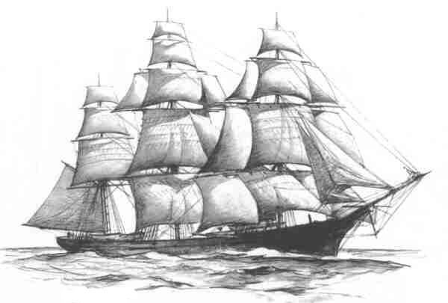“Following the light of the sun, we left the Old World.”

-Christopher Columbus